***A Mini Project Report on***

**AEROSPACE MANAGEMENT SYSTEM**

**T. E.  Computer Engineering-A**

**Submitted By**

**Arnold Dsouza 23**

**Misaal D’souza  25**

**Crystal Fargose 27**

**Under The Guidance Of**

**(Ms. Pradnya Rane)**



ST. FRANCIS INSTITUTE OF TECHNOLOGY

(ENGINEERING COLLEGE)

Mount Poinsur S.V.P Road, Borivali (W), Mumbai-400103

UNIVERSITY OF MUMBAI

2020-21

**CERTIFICATE**

This to certify that the Mini Project report on '**Aerospace Management System**' has been carried out by **Arnold D’souza, Misaal D’souza & Crystal Fargose**(TE/CMPN-A/(23-25-27), who are bonafide students of St. Francis Institute of Technology, Mumbai in partial fulfilment of the requirement of T. E. degree in Computer Engineering at St. Francis Institute of Technology, Mumbai, India. It is also certified that this work has not been presented anywhere else for award of any other degree or diploma prior to this.

**Project  Incharge:**

**(Ms. Pradnya Rane)**

**Internal Examiner       External Examiner**

**_________________________         __________________________**

**(                                             )           (                     )**

**TABLE OF CONTENTS**

|  |  |  |
| --- | --- | --- |
| **Chapter No** | **Contents** | **Page No** |
| 1 | Introduction | 4 |
| 2 | System Requirements Specification | 5 |
| 3 | System Environment | 6 |
| 4 | System Design | 6-7 |
| 5 | Code | 8-14 |
| 6 | ER_Diagram & Relational Model | 15-16 |  |
| 7 | Conclusion | 17 |
| 8 | Screenshots | 18 |

**INTRODUCTION**

To develop a database system which will store information and the task carried out by the astronauts. There are different systems in space which receive information and are a connected entity. For e.g. which astronaut is working at the space station. It will also include information on communications, space missions ,navigation through radio signals ,planetary exploration and finding habitable planet. It consists of total seven entitites. These systems are connected to each other with a relationship, like one space station during the dock craft viz. the relationship and the spacecraft viz. the entity allows docking process which is the relationship.

**SYSTEM REQUIREMENTS**

1. Software Requirements Specification:

Every software is expected to live up to a certain standard, in order to maintain functionality and usability. Our web-app is very user friendly with minimal input elements, a good background and colour scheme that makes the action buttons easily understandable even to a new user.

2. User Interface Requirements:

The user interface should be friendly and easy to grasp. If a UI is confusing the user tends to avoid using it. It should also have an attractive look to gain the preference of the user. Another important factor is flexibility or customization.

3. Database Requirements

The database should be designed in an organised manner so that the data is segregated to enhance understanding and usability. Similar elements should be grouped together to facilitate the user’s ability to understand and use the data stored within the database effectively and efficiently.

**SYSTEM ENVIRONMENT**

1. Hardware

The hardware environment consists of the following :

CPU : Intel Pentium IV 600MHz

Mother Board : Intel 810

Hard disk space : 20GB or more

Display : 15” Monitor

Memory : 128 MB RAM

Other Devices : Color Monitor, Keyboard, mouse.

2. Software

The software used for creating this project includes:

Text editor : Atom

Front end : HTML5, CSS, JavaScript

Back end : php, MySQL

Operating System : Windows 10

Web server : wix.com/000webhost.com, XAMPP server

**SYSTEM DESIGN**

1. Input Design

The input field is shown where the user can enter the values. These interactions should take minimum effort, be quick and achieve the desired result with as little hindrance as possible. Any unnecessary time-consuming activities should be avoided such as long animations, unnecessary scrolling, displaying each input field on separate pages, etc.

2. Output Design

The output is a table which shows the value inserted. The user after updating or deleting or searching for a particular field is also done and displayed.

3. Database Design

Database stores data in the form of tables. Database design involves giving a structure to these tables so that they’re efficient at storing more data in less space. Performing operations on these data entries should also be easy and not tedious. The following are the tables in our database:

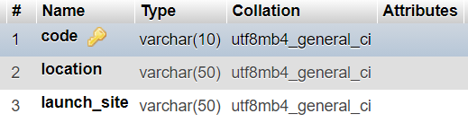

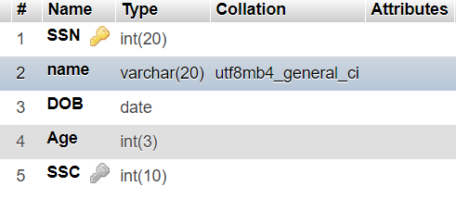

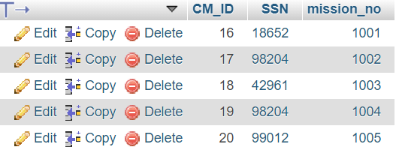

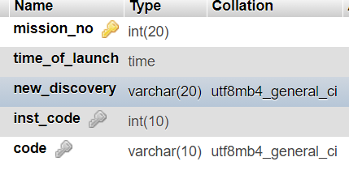

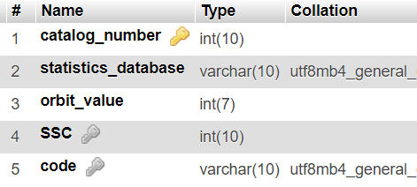

MAIN FRONT-END CODE:

<?php

$link = mysqli_connect("localhost","root","");

mysqli_select_db($link,"useraccounts");

?>

<!DOCTYPE html PUBLIC "-//W3C//DTD HTML 4.01 Transitional//EN" "http://www.w3.org/TR/html4/loose.dtd">

<html>

<head>

<title>Agency</title>

<link rel="stylesheet" type="text/css" href="css/bootstrap.min.css">

<link rel="stylesheet" href="agencystyle.css">

<title>Untitled Document</title>

<meta http-equiv="Content-Type" content="text/html; charset=iso-8859-1">

</head>

<body>

<div>

<form name="form1" action="" method="post">

<div class="container">

<div class="row">

<div class="col-sm-4">

<h2>Agency Registration</h2>

<hr class="mb-3">

<label for="code"><b>Code</b></label>

<input class="form-control" type="number" name="t1">

<label for="location"><b>Location</b></label>

<input class="form-control" type="text" name="t2">

<label for="launch_site"><b>Launch Site</b></label>

<input class="form-control" type="text" name="t3">

<hr class="mb-4">

<input class="btn btn-outline-success" type="submit" name="submit1" value="insert">

<input class="btn btn-outline-danger" type="submit" name="submit2" value="delete" >

<input class="btn btn-outline-warning" type="submit" name="submit3" value="update"><p> </p>

<input class="btn btn-outline-info" type="submit" name="submit4" value="display">

<input class="btn btn-outline-primary" type="submit" name="submit5" value="search">

</div>

</div>

</div>

</form>

</div>

</body>

<?php

if(isset($_POST["submit1"]))

{

mysqli_query($link,"INSERT INTO agency VALUES('$_POST[t1]','$_POST[t2]','$_POST[t3]')");

}

if(isset($_POST["submit2"]))

{

mysqli_query($link,"DELETE FROM agency where code='$_POST[t1]'");

}

if(isset($_POST["submit3"]))

{

mysqli_query($link,"update agency set code='$_POST[t2]' where code='$_POST[t1]'");

}

if(isset($_POST["submit4"]))

{

$res = mysqli_query($link,"select * from agency");

echo "<div>";

echo "<table class='table' border='5px' align='center'>";

echo "<thead class='thead-dark'>";

echo "<tr>";

echo "<th scope='col'>"; echo "Code" ; echo "</th>";

echo "<th scope='col'>"; echo "Location"; echo "</th>";

echo "<th scope='col'>"; echo "Launch Site"; echo "</th>";

echo "</tr>";

echo "</thead>";

echo "<tbody>";

while($row=mysqli_fetch_array($res))

{

echo "<tr>";

echo "<td>"; echo $row["code"] ; echo "</td>";

echo "<td>"; echo $row["location"]; echo "</td>";

echo "<td>"; echo $row["launch_site"]; echo "</td>";

echo "</tr>";

}

echo "</tbody>";

echo "</table>";

echo "</div>";

}

if(isset($_POST["submit5"]))

{

$res = mysqli_query($link,"select * from agency where code='$_POST[t1]'");

echo "<table class='table' border='5px' align='center'>";

echo "<thead class='thead-dark'>";

echo "<tr>";

echo "<th scope='col'>"; echo "Code" ; echo "</th>";

echo "<th scope='col'>"; echo "Location"; echo "</th>";

echo "<th scope='col'>"; echo "Launch Site"; echo "</th>";

echo "</tr>";

echo "</thead>";

echo "<tbody>";

while($row=mysqli_fetch_array($res))

{

echo "<tr>";

echo "<td>"; echo $row["code"] ; echo "</td>";

echo "<td>"; echo $row["location"]; echo "</td>";

echo "<td>"; echo $row["launch_site"]; echo "</td>";

echo "</tr>";

}

echo "</tbody>";

echo "</table>";

}

?>

</html>

DATABASE CODE ( ___EntityName___)

____Agency_____

CREATE TABLE Agency(

agency_code number(10) primary key,

location varchar2(50),

launch_site varchar2(50)

);

___Space_Station___

CREATE TABLE Space_Station(

SSC number(10) primary key,

no_of_astronauts number(10),

experiment_labs number(5)

);

___Satellite____

CREATE TABLE Satellite(

catalog_number number(10) primary key,

statistics varchar2(10),

orbit_value number(7),

SSC,

agency_code,

foreign key (SSC) references space_station(SSC),

foreign key(agency_code) references Agency(agency_code)

);

___Astronaut___

CREATE TABLE Astronaut(

SSN number(10) primary key,

name varchar2(20),

DOB Date,

Age number(2),

SSC,

foreign key(SSC) references space_station(SSC)

);

___Spacecraft___

CREATE TABLE Spacecraft(

instrument_code number(5) primary key,

capacity number(5),

navigation_system varchar2(25),

SSC,

foreign key(SSC) references space_station(SSC)

);

___Missions_____

CREATE TABLE Missions(

mission_number number(5) primary key,

date_time_of_launch date,

new_discoveries varchar2(50),

instrument_code,

agency_code,

foreign key(instrument_code) references spacecraft(instrument_code),

foreign key(agency_code) references agency(agency_code)

);

___CommissioningMissions___

CREATE TABLE CommissioningMissions(

CM_ID number(1),

SSN,

mission_number,

foreign key(SSN) references astronaut(SSN),

foreign key(mission_number) references missions(mission_number)

);

ER Model :

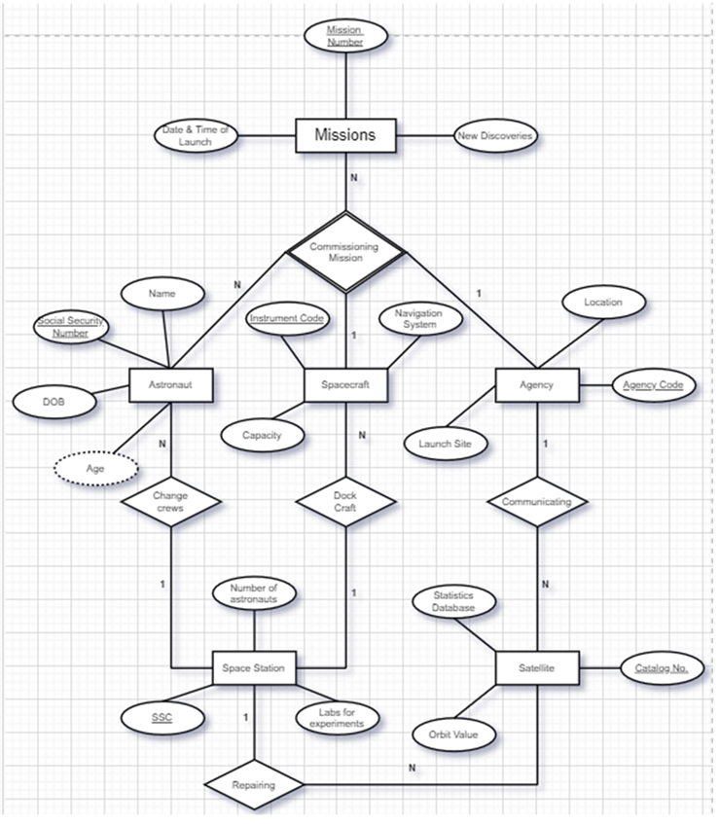

Relational Model:

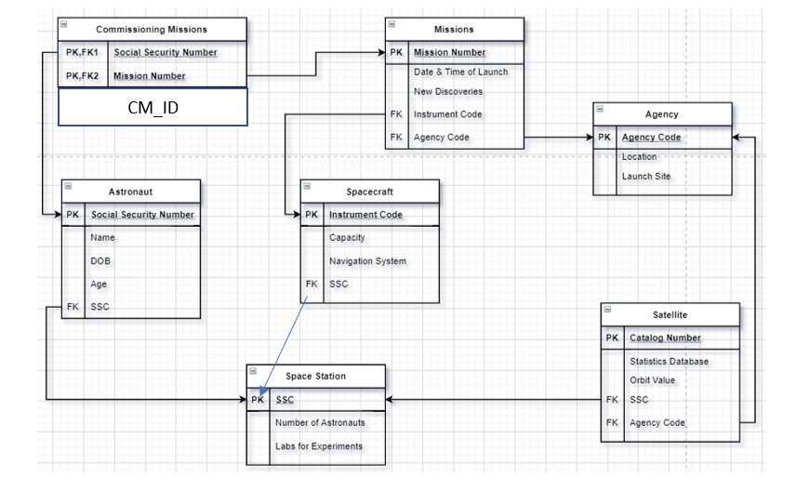

**CONCLUSION :**

We have successfully accomplished what we set out to do, i. e. create a computer web application that manages aerospace information which gets stored into database and it gives proper information to the user in a tabular form. In doing so we have gained confidence in our ability to create more applications and will use this project experience while making web-apps in the future, with even better more ironed out functions.

**SCREENSHOTS**

